EE 5356_ DIGITAL IMAGE PROCESSING

ASSIGNMENT- 8

NAME: PAVAI ARCHIMEDES

ST ID: 1001233996

MATLAB CODE:

Function program:

function output = invgau (in,sig,no)

[r c]= size(in);

for i = 0:(r-1)

for j = 0:(r-1)

if( i <=(r/2) && j <=(c/2))

g(i+1,j+1) = exp(((i*i)+(j*j))/(2*sig));

elseif( i >=(r/2) && j >=(c/2))

g(i+1,j+1) = g(r-i+1,c-j+1);

end

end

end

figure(no);

surf( g, 'EdgeColor', 'none');

colormap(hsv);

shading interp;

alpha(0.7);

grid on;

axis tight;

if( no == 1)

title('IGF of lena512.bmp');

elseif(no == 2)

title('IGF of goldhill256.bmp');

elseif(no == 3)

title('IGF of boat512.gif');

elseif(no == 4)

title('IGF of girl512.bmp');

end

output = in.*g;

end

MAIN PROGRAM:

clc;

clear all;

close all;

lena = imread('C:\Users\PAVAI ARCHIMEDES\Desktop\lena512.bmp');

igold = imread('C:\Users\PAVAI ARCHIMEDES\Desktop\goldhill256.bmp');

iboat = imread('C:\Users\PAVAI ARCHIMEDES\Desktop\boat512.gif');

igirl = imread('C:\Users\PAVAI ARCHIMEDES\Desktop\girl512.bmp');

f1 = fft2(image1lena);

f2 = fft2(igold);

f3 = fft2(iboat);

f4 = fft2(igirl);

sig1 = 15707;

sig2 = 28198;

sig3 = 41694;

sig4 = 34657;

ilena1_igf = invgau (f1,sig1,1);

igold2_igf = invgau (f2,sig2,2);

iboat3_igf = invgau (f3,sig3,3);

igirl4_igf = invgau (f4,sig4,4);

final1 = ifft2(ilena1_igf);

final2 = ifft2(igold2_igf);

final3 = ifft2(iboat3_igf);

final4 = ifft2(igirl4_igf);

figure ;

subplot(2,2,1);

imshow(image1lena);

title('Original Image Lena');

subplot(2,2,2);

imshow(uint8(final1));

title('Filtered Image Lena');

subplot(2,2,3);

imshow(igold);

title('Original Image Goldhill');

subplot(2,2,4);

imshow(uint8(final2));

title('Filtered Image Goldhill');

figure ;

subplot(2,2,1);

imshow(iboat);

title('Original Image Boat');

subplot(2,2,2);

imshow(uint8(final3));

title('Filtered Image Boat');

subplot(2,2,3);

imshow(igirl);

title('Original Image Girl');

subplot(2,2,4);

imshow(uint8(final4));

title('Filtered Image Girl');

OUTPUT:

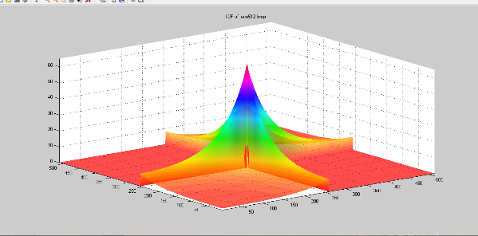

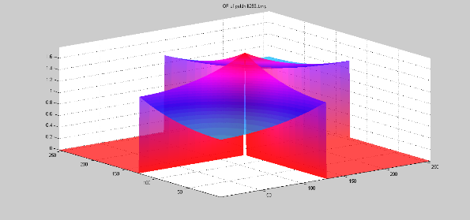

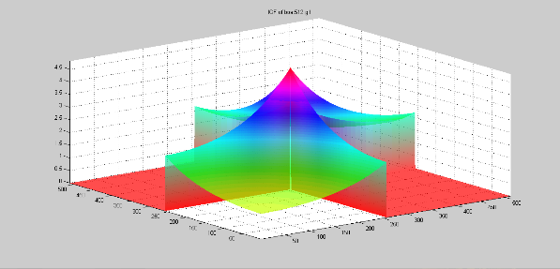

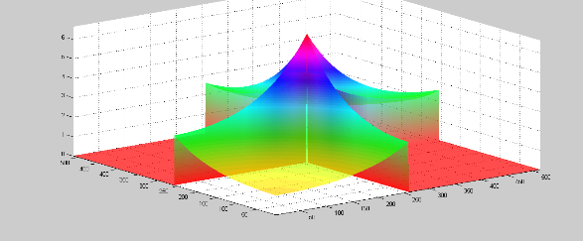

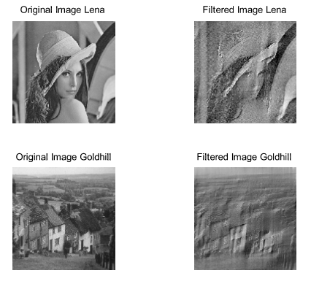

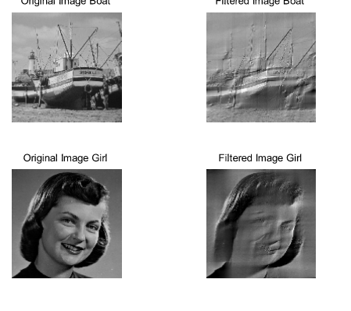

CONCLUSION:

Here I have applied IGF to test images and displayed 3D IGF plot . From this project I have understood the Gaussian filter property of blurring images by default.